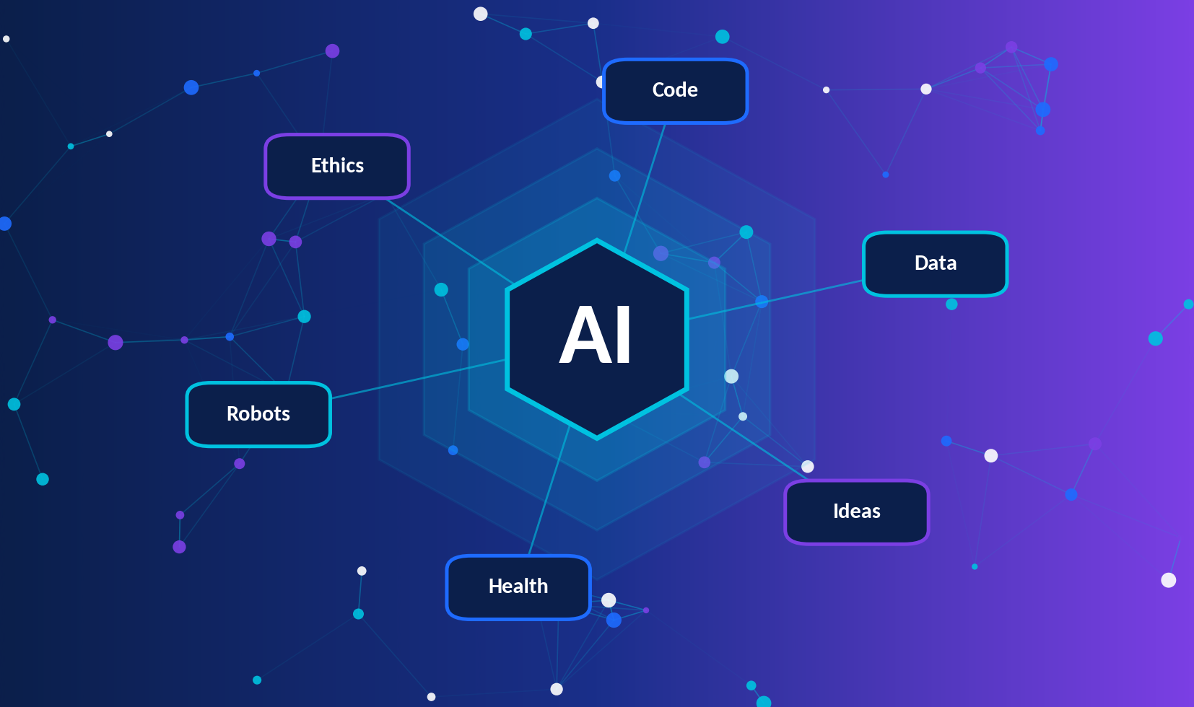
MONTH 4 · UNIT 4
AI & Career
Student Workbook
Topic 1 AI Career Universe
Topic 2 Create Your Career Blueprint

CLASS 11 · AI OLYMPIAD
Careers, skills, learning pathways and your personal AI Career Blueprint
Student name
Class and section
School
Teacher / Date
Month 4 · Unit 4 only | Editable student workbook | Includes worksheets, projects, assessment and answer key

CONTENTS
Table of Contents
About This Workbook 3
Part A · AI Career Universe 4
Chapter 1: Introduction to AI Careers and the Future of Work 4
Chapter 2: The AI Career Map – Roles in Detail 6
Chapter 3: Skills for AI Careers 10
Chapter 4: AI Careers Across Industries 12
Chapter 5: Benefits, Challenges and Responsible AI Careers 13
Worksheet 1: Career Exploration – AI Roles 15
Worksheet 2: Career Exploration – Skills and Industries 17
Part B · Create Your Career Blueprint 19
Chapter 6: Learning Pathways, Portfolios and Experience 19
Chapter 7: Know Yourself, Set Goals, Build Your Roadmap 21
Worksheet 3: Career Exploration – Pathways and Responsible AI 24
Worksheet 4: Career-Interest Self-Reflection 26
Worksheet 5: Personal Skills Assessment and Goal-Setting 28
Worksheet 6: My AI Career Blueprint (Step-by-Step Template) 30
Case Studies: People in AI-Related Careers 32
Mini-Project: Design Your Personal AI Career Roadmap 34
Part C · Practice, Revision and Assessment 35
Practice Questions 35
Classroom Activities 40
Puzzles and Challenges 43
Quick Revision Quiz 45
Concept Map 46
Chapter Summary 46
Glossary 47
Unit Assessment (30 Marks) 48
Answer Key and Suggested Answers 51

Note on page numbers
Page numbers refer to this document. If you edit and add pages, right-click inside Word and update the contents list manually, or use the Navigation Pane (View → Navigation Pane), because all chapters use Word’s built-in heading styles.

About This Workbook
Welcome to Month 4 – Unit 4: AI & Career. This unit has two topics from the Class 11 AI Olympiad syllabus:
Topic | Title | What you will do
1 | AI Career Universe | Discover AI careers, the skills they need, the industries they serve, and how the world of work is changing.
2 | Create Your Career Blueprint | Understand yourself, set goals and build a personal AI career roadmap with learning, projects and experience.

By the end of this unit you will be able to
- describe at least ten AI-related careers, including their roles, skills and learning pathways;
- separate what is happening today from what is only a possible future;
- name the technical and soft skills that AI careers rely on and rate your own;
- explain how AI is used in healthcare, education, agriculture, business, transport and other fields;
- build a portfolio plan, find learning resources and spot safe internship opportunities;
- write SMART goals and complete a personal AI Career Blueprint;
- discuss the benefits, challenges, lifelong learning needs and responsible-AI duties of AI careers.

How to use the workbook
Symbol / label | Meaning
● TODAY | Something that is already happening and can be checked in the real world.
◆ FUTURE | A possibility or prediction. Experts may disagree; it is not guaranteed.
Writing lines | Space for your own answers. Write in pencil first, then review.
Think & Try boxes | Short activities you can do on the spot or at home.

Please read: no career guarantees
This workbook introduces careers so that you can make informed choices. No career, course or certificate guarantees a job or a particular salary. Job titles, tools and demand change over time and differ between countries and employers. Always check current information from official, trustworthy sources before making big decisions.


Part A · AI Career Universe
Topic 1 of Unit 4: explore the roles, skills and industries that make up the world of AI careers.

Chapter 1: Introduction to AI Careers and the Future of Work

1.1 What is an “AI career”?
An AI career is a job where people design, build, test, apply, manage or guide artificial intelligence, or use AI as a major part of their daily work. It is not only for programmers. Teams also need people who understand users, data, law, ethics, design, language and the subject being served (such as medicine or farming).
Real-life example: one app, many careers
A farmer takes a photo of a spotted leaf and an app suggests the likely disease. Behind that simple moment are an agronomist who knows plant diseases, a data analyst who cleans thousands of leaf photos, a computer vision engineer who trains the model, an AI engineer who puts it inside a phone app, a product manager who talks to farmers, and an ethics specialist who checks that the advice is safe and fair.

1.2 The future of work: what is real and what is possible?
People often make bold claims such as “AI will take all jobs” or “AI will not change anything”. Neither is a good scientific statement. A better approach is to separate evidence from prediction.
Area | ● TODAY Already happening | ◆ FUTURE Possible, uncertain
Tasks | AI tools help with translation, writing support, image analysis, recommendations and customer-service chats. | AI systems may handle longer, multi-step tasks with less human input in some workplaces.
Jobs | Many jobs are changing: some tasks are automated while people focus on checking, deciding and communicating. | New job titles may appear and some may fade. Experts disagree about how fast this will happen.
Skills | Job advertisements in many fields now mention data, AI literacy or digital skills. | Skills such as judgement, creativity and responsible use may become even more valuable.
Learning | Free and paid online courses, open datasets and communities make it easier to start learning. | Personalised AI tutors may change how people train for careers.

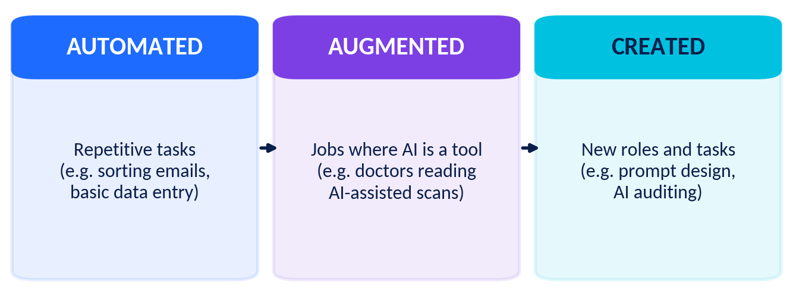
Figure 1.1 AI often changes parts of a job (tasks) rather than removing the whole job.

1.3 Thinking in tasks, not just jobs
Every job is a bundle of tasks. AI may automate some tasks, assist with others and leave some mostly human. Consider a radiology technician: AI may help highlight areas of a scan ● TODAY but the person still positions the patient, checks quality, talks to doctors and cares for people. Ask: *Which of my future job’s tasks need empathy, judgement, creativity or physical skill?*

1.4 AI is a team sport
Building a useful AI system takes several stages, and each stage needs different people. Figure 1.2 shows a simplified pipeline and who typically works on each stage.
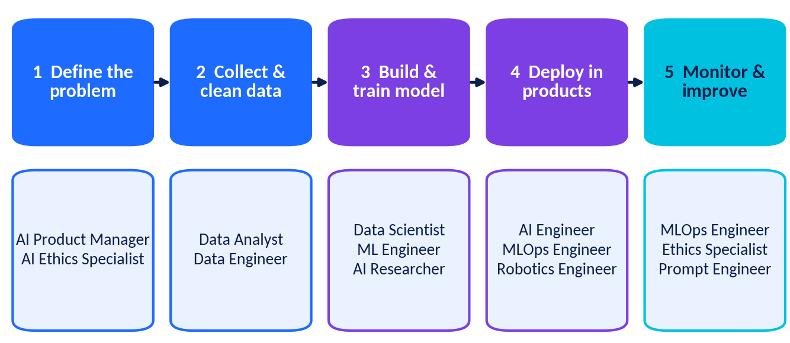
Figure 1.2 The AI project pipeline and the roles involved (simplified; real teams vary).

1.5 Five families of AI careers
Family | Main question | Example roles
Build | How do we make this work inside a product? | AI Engineer, ML Engineer, MLOps Engineer
Discover | What does the data tell us? What new method is possible? | Data Scientist, Data Analyst, AI Researcher
Sense & Move | How can machines see, hear and act in the physical world? | Robotics Engineer, Computer Vision Engineer
Guide | What should we build, and how should people talk to AI? | AI Product Manager, Prompt Engineer
Govern | Is it fair, safe, private and legal? | AI Ethics Specialist, AI Policy Analyst

Think & Try (5 minutes)
Choose any app you use daily (maps, music, shopping, video). Write down three ways AI might be used inside it and one job that someone must do to keep it working.

Chapter 2: The AI Career Map – Roles in Detail
Figure 2.1 shows twelve roles in the AI career universe. The inner ring contains roles close to data and models; the outer ring contains roles in research, machines, guidance and governance. Use the profile cards on the next pages to compare them.
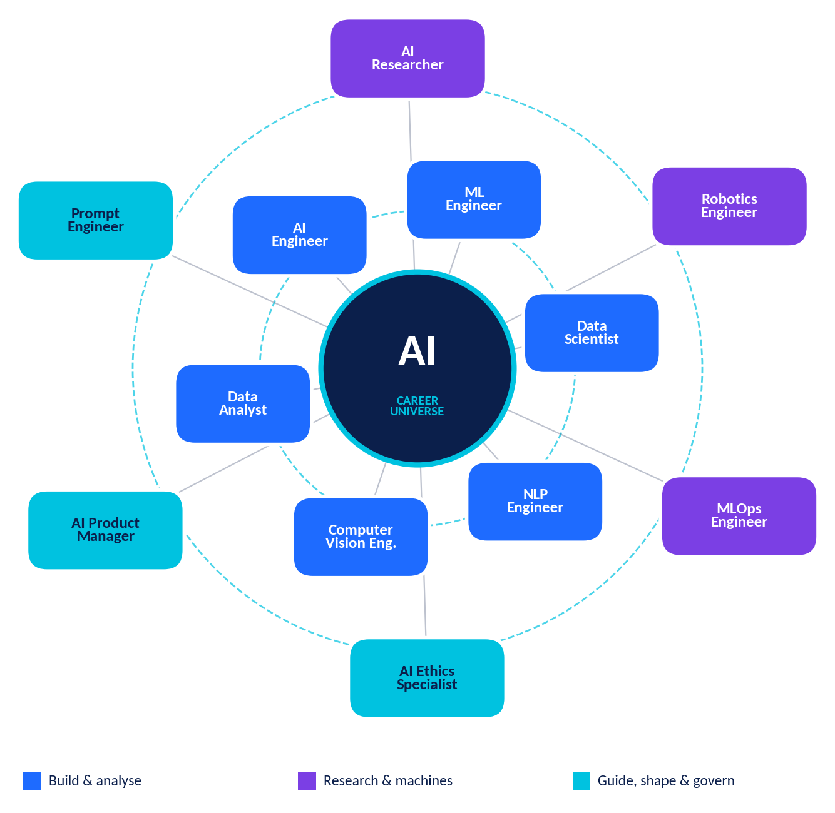
Figure 2.1 The AI Career Universe: twelve roles around the core of AI.
Reading the profiles
Educational pathways shown are typical examples. Names of degrees, eligibility rules and job requirements differ between countries, boards, universities and employers. Many people also enter AI from other fields. Always check official sources.

2.1 Profile cards
1. AI Engineer Builds real products and systems that use AI models.
What they do | • Connect trained models to apps, websites and devices using APIs.  • Build data and model pipelines; test speed, accuracy and cost.  • Work with software, design and product teams.
Key skills | Python, software engineering (Git, APIs, testing), ML basics, cloud basics, debugging.
Education pathway | Degree such as B.Tech/B.E./B.Sc. in Computer Science, IT, AI or Data Science (or equivalent) plus projects.
Real-world use | A bank’s customer-support chatbot; a photo app that groups pictures by faces and places; voice features in cars.
Common tools | Python, PyTorch/TensorFlow, REST APIs, Docker, cloud platforms.

2. Machine Learning (ML) Engineer Trains, tunes and prepares ML models so they work in the real world.
What they do | • Prepare features and datasets; train and compare models.  • Evaluate results and fix problems such as overfitting.  • Work with data scientists and MLOps engineers to deploy models.
Key skills | Python, linear algebra, probability, ML algorithms, scikit-learn, PyTorch, clean coding.
Education pathway | Degree in Computer Science, Mathematics, Statistics or Engineering; some roles prefer a Master’s degree.
Real-world use | Recommending videos; spotting suspicious card payments; predicting when a machine may fail.
Common tools | scikit-learn, PyTorch, TensorFlow, Jupyter, Git.

3. Data Scientist Uses data, statistics and ML to answer questions and guide decisions.
What they do | • Turn a real problem into a data question.  • Clean and explore data; build statistical or ML models.  • Explain findings clearly to non-experts.
Key skills | Statistics, Python or R, SQL, visualisation, storytelling, curiosity.
Education pathway | Degree in Statistics, Mathematics, Computer Science, Economics or another quantitative subject, plus data projects.
Real-world use | Forecasting hospital bed demand; studying factors affecting crop yield; finding why customers stop using a service.
Common tools | Python (pandas, scikit-learn), SQL, notebooks, Power BI/Tableau.

4. Data Analyst Turns data into reports, dashboards and clear recommendations.
What they do | • Collect and clean data from spreadsheets and databases.  • Answer business questions using SQL and charts.  • Present insights to managers, teachers or customers.
Key skills | Spreadsheets, SQL, basic statistics, visualisation, communication, attention to detail.
Education pathway | Degree in almost any numerate subject plus data skills; often a first step towards data science.
Real-world use | A school finding attendance patterns; a shop tracking which products sell best each month.
Common tools | Excel/Google Sheets, SQL, Power BI/Tableau, Python basics.

5. Robotics Engineer Designs, builds and programs machines that sense, decide and act.
What they do | • Design mechanical and electronic parts of robots.  • Program sensors, motors and control software; add AI for vision or navigation.  • Test for safety and reliability.
Key skills | Python/C++, physics, electronics, control systems, CAD, teamwork, patience.
Education pathway | Degree in Robotics, Mechatronics, Mechanical, Electronics or Computer Engineering.
Real-world use | Warehouse robots, surgical-assist systems, agricultural drones and planetary rovers.
Common tools | ROS (Robot Operating System), Arduino/Raspberry Pi, CAD, simulators.

6. AI Researcher Investigates new ideas and methods that push AI forward.
What they do | • Read scientific papers and design experiments.  • Develop and test new algorithms or analyse existing ones.  • Publish results and share code with the community.
Key skills | Advanced mathematics, programming, scientific writing, persistence, critical thinking.
Education pathway | Often a Master’s or PhD in Computer Science, Mathematics, Statistics or related fields for research positions in universities and labs.
Real-world use | More efficient learning methods; better medical-image analysis; methods to make AI safer and more explainable.
Common tools | Python, PyTorch/JAX, LaTeX, research databases, GPU computing.

7. Prompt Engineer Designs and tests instructions and workflows for generative AI systems.
What they do | • Write, test and improve prompts; build sets of test questions.  • Document what works and where AI makes mistakes.  • Work with experts in a subject to check the answers.
Key skills | Clear writing, logical thinking, subject knowledge, testing mindset; basic Python helps.
Education pathway | Varied: language, computer science or subject-expert backgrounds; portfolios of tested prompts matter.
Real-world use | A study helper that explains steps; a support assistant for a company; draft tools that always need human review.
Common tools | Chat-based AI tools, notebooks, evaluation spreadsheets, APIs.
Note | ● TODAY This is a newer, fast-changing role. Many organisations now treat prompting as a skill inside other roles, so job titles may differ.

8. AI Product Manager Decides what AI product to build and why, linking users, business and engineers.
What they do | • Study user needs; define goals and success measures.  • Prioritise features, budget and timelines.  • Raise questions about risk, privacy and fairness early.
Key skills | Communication, problem framing, understanding of ML basics, data-informed decisions, leadership.
Education pathway | Any degree plus experience; many start as engineers, analysts or designers. An MBA is optional.
Real-world use | Planning an AI tutor app; designing a hospital appointment assistant.
Common tools | Roadmaps, user research, dashboards, project-tracking tools.

9. AI Ethics Specialist (Responsible AI) Helps make AI fair, safe, transparent and legally compliant.
What they do | • Review data and models for bias and privacy risks.  • Write guidelines and run risk assessments.  • Train teams and talk with users, regulators and communities.
Key skills | Critical thinking, ethics and law basics, data literacy, communication, empathy.
Education pathway | Law, philosophy, social science, public policy, computer science or combinations, plus AI literacy.
Real-world use | Checking a job-screening tool for unfair patterns; reviewing a health app’s data practices.
Common tools | Risk checklists, fairness-testing tools, policy documents.

10. Computer Vision Engineer Teaches computers to understand images and video.
What they do | • Build image classifiers and object detectors.  • Label and improve image datasets.  • Make models run on phones, cameras and robots.
Key skills | Python, linear algebra, deep learning (CNNs), OpenCV, testing in real conditions.
Education pathway | Computer Science, Electronics, Mathematics or AI degrees; projects with images.
Real-world use | Supporting doctors with scan analysis; plant-disease detection from phone photos; quality checks in factories.
Common tools | OpenCV, PyTorch, TensorFlow, annotation tools.

11. Natural Language Processing (NLP) Engineer Builds systems that work with human language: text and speech.
What they do | • Create translation, summarising, search and chatbot features.  • Test performance across languages and dialects.  • Handle sensitive text carefully.
Key skills | Python, ML, basic linguistics, transformer models, evaluation methods.
Education pathway | Computer Science, Linguistics with programming, Mathematics, or AI degrees.
Real-world use | Voice assistants in Indian and other languages; translating textbooks; spam filters.
Common tools | Hugging Face, spaCy, PyTorch, speech toolkits.

12. MLOps Engineer Keeps ML systems running reliably after they are launched.
What they do | • Build automated pipelines for training and deployment.  • Track data and model versions.  • Monitor for errors and “drift” when the world changes.
Key skills | Python, Linux, Docker, cloud services, automation, monitoring.
Education pathway | Computer Science, IT or Software Engineering; often grows from software or data engineering.
Real-world use | Making sure a delivery app’s arrival-time model stays accurate when traffic patterns change.
Common tools | Docker, Kubernetes, CI/CD tools, cloud ML platforms, monitoring dashboards.

2.2 More careers to explore
Career | Short description
Data Engineer | Builds and maintains the systems that collect, store and move data for analysts and ML teams.
AI Policy Analyst | Studies laws and standards for AI and advises governments, companies or non-profits.
Conversational Designer | Designs how chatbots and voice assistants talk, so conversations feel clear and helpful.
Bioinformatics / Health-AI Scientist | Applies data and ML to biology and medicine, such as analysing genetic or clinical data.
AI Educator / Trainer | Teaches AI skills in schools, colleges and workplaces and designs learning materials.
UX Designer for AI | Designs interfaces so people can understand, trust and correct AI features.
AI Security Specialist | Protects AI systems and data from attacks, misuse and leaks.

Chapter 3: Skills for AI Careers
AI careers combine technical skills (what you can build and analyse) with soft skills (how you think, communicate and work with people). Employers value both; the best AI practitioners keep improving in each area.

3.1 Technical skills
Skill | What it means | Grade 11 starting point
Python | A readable programming language used for data analysis, ML and automation. | Variables, loops, functions, lists; solve small problems on free coding sites.
Mathematics | Linear algebra (vectors, matrices), calculus (how models improve step by step) and probability (uncertainty). | Strengthen functions, sequences, matrices, coordinate geometry and probability from your school syllabus.
Statistics | Describing and understanding data: mean, median, spread, correlation, sampling, bias. | Practise with real data such as class heights or match scores.
Data analysis | Collect, clean, explore, visualise and explain data. | Use a spreadsheet to clean and chart a small dataset.
Machine learning | Methods that let computers learn patterns from data (supervised, unsupervised, reinforcement learning). | Learn the ideas first; then try a simple classifier on a beginner dataset.
AI tools | Notebooks, code hosting, ML libraries, model hubs and AI assistants. | Try Jupyter or Google Colab, GitHub, and a beginner Kaggle notebook.

A tiny taste of Python
scores = [72, 85, 90, 64, 78]
average = sum(scores) / len(scores)
print("Average score:", average)
passed = [s for s in scores if s >= 75]
print("Scores of 75 or more:", passed)
This program finds the average of five scores and then keeps only the scores that are 75 or more. The output is Average score: 77.8 and Scores of 75 or more: [85, 90, 78]. Real AI work uses the same idea on millions of values.
Statistics in one example
Five students spent 2, 3, 3, 4 and 48 minutes on a task (one student left the page open). The mean is 12 minutes but the median is 3 minutes. The median describes the typical student better because the extreme value (an outlier) pulls the mean upwards. Data scientists check for outliers before trusting an average.
Remember: correlation is not causation
Ice-cream sales and sunburn cases both rise in summer. They move together (correlation), but ice-cream does not cause sunburn: hot, sunny weather affects both. Good analysts look for hidden factors before claiming one thing causes another.
Three types of machine learning
Type | Idea | Example
Supervised | Learn from examples with correct labels. | Photos labelled “healthy leaf” or “diseased leaf” train a classifier.
Unsupervised | Find patterns in data without labels. | Grouping shoppers with similar buying habits.
Reinforcement | Learn by trial and error using rewards. | A robot learning to balance or a game-playing agent.

Using AI tools responsibly while you learn
AI assistants can explain ideas and help debug code, but they can also make mistakes. Check their answers, try to understand each step, follow your school’s rules about homework and exams, and never share private information about yourself or others.

3.2 Soft skills
Soft skill | What it looks like in AI work | How to practise now
Communication | Explaining a model’s results to a doctor, farmer or manager without jargon; writing clear documentation. | Present a project in two minutes to a friend who has no coding background.
Creativity | Imagining new uses for data, designing better user experiences, finding unusual solutions. | Invent three different ways to solve one school problem using data.
Teamwork | Working with engineers, designers, subject experts and users; sharing credit and feedback. | Join a group project; use shared tools and agree on roles.
Critical thinking | Questioning data quality, spotting bias, checking whether a result makes sense. | Compare two news reports on the same AI claim and list the evidence in each.
Problem-solving | Breaking a big problem into small steps, testing ideas, learning from errors. | Debug a short program step by step and write what you learned.

3.3 Which skills matter most for which careers?
The heat-map below shows the typical emphasis of each skill area. Real jobs differ; use it to start conversations, not to limit yourself.
Career | Coding | Maths / stats | Creativity | Communication | Ethics & policy
AI Engineer | High | Med | Med | Med | Med
ML Engineer | High | High | Med | Med | Med
Data Scientist | High | High | Med | High | Med
Data Analyst | Med | Med | Med | High | Low
Robotics Engineer | High | High | High | Med | Med
AI Researcher | High | High | High | Med | Med
Prompt Engineer | Med | Low | High | High | Med
AI Product Manager | Low | Low | High | High | High
AI Ethics Specialist | Low | Low | Med | High | High
Computer Vision Eng. | High | High | Med | Med | Med
NLP Engineer | High | High | Med | Med | Med
MLOps Engineer | High | Med | Low | Med | Low
Table 3.1 Typical skill emphasis by career (High / Medium / Low). Varies by employer and team.

Chapter 4: AI Careers Across Industries
AI is a general-purpose technology, like electricity or the internet. That means careers appear in almost every sector, often combining AI with deep subject knowledge.
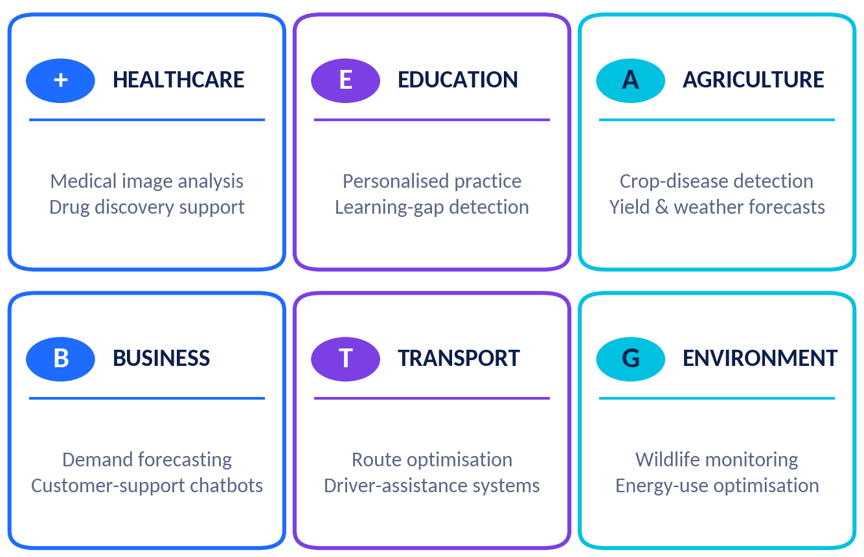
Figure 4.1 Six sectors using AI today, with example applications.
Industry | ● TODAY How AI is used | Careers involved | ◆ FUTURE Possible direction
Healthcare | Supporting doctors in reading scans; helping predict patient risk; speeding up some drug-research steps. Humans make final decisions. | Health-AI scientist, ML engineer, clinical data analyst, ethics specialist | More personalised treatment plans; AI helpers for routine paperwork.
Education | Practice platforms that adapt to a learner; translation and accessibility tools; spotting learning gaps. | AI educator, learning-data analyst, NLP engineer, product manager | More personalised tutoring, if privacy and fairness are protected.
Agriculture | Phone apps that identify crop diseases; weather and yield forecasting; drones for field monitoring. | Computer vision engineer, data scientist, robotics engineer, agronomist | More precise use of water and fertiliser; low-cost tools for small farms.
Business & finance | Demand forecasting; recommendation engines; chatbots; fraud detection. | Data analyst, AI engineer, MLOps engineer, product manager | More automation of routine reporting and support tasks.
Transportation | Route planning; traffic prediction; driver-assistance features; delivery optimisation. | Robotics engineer, ML engineer, safety engineer, data scientist | Wider use of self-driving features in limited settings, depending on safety and regulation.
Environment & energy | Analysing satellite and camera-trap images; forecasting electricity demand. | Data scientist, computer vision engineer, climate-data analyst | Better modelling of climate risks and smarter energy grids.
Media & creativity | Tools for editing, translation, captioning and idea generation. | Prompt engineer, creative technologist, ethics and rights specialist | New creative workflows; ongoing debates about credit and copyright.
Public services | Traffic management, document search and translation, citizen-help chatbots. | Policy analyst, data analyst, AI engineer | Faster services, with strong needs for transparency and oversight.

Real-life example: AI-assisted eye screening
Several health systems have tested and used AI tools that analyse photographs of the retina to help screen for diabetic eye disease, so that people can be referred to eye doctors sooner. These tools are supported by doctors, technicians, data scientists and regulators, and their performance is checked on many different patient groups. The lesson: AI careers in health combine technology with care, evidence and ethics.

Chapter 5: Benefits, Challenges and Responsible AI Careers

5.1 Benefits and challenges at a glance
Possible benefits | Possible challenges
Work on meaningful problems in health, learning, farming, climate and more. | Tools and methods change quickly, so you must keep learning.
Many entry routes: engineering, analysis, design, policy, research, communication. | Competition for some roles can be strong; job openings vary by place and time.
Mix of analytical thinking and creativity; chance to build things people use. | Handling biased data, privacy and misuse brings real ethical responsibility.
Opportunities to collaborate with people from different fields and countries. | Projects can be uncertain: models sometimes fail and need many rounds of testing.
Skills such as data literacy and problem-solving transfer to other careers. | Access to computers, internet and mentors is not equal for everyone.
Table 5.1 Balanced view: benefits and challenges. Outcomes depend on individuals and circumstances; no result is guaranteed.

5.2 Changing job roles
Careers rarely stay the same for 40 years. Titles such as “data scientist” and “prompt engineer” did not exist in the same form a few decades ago. Three patterns are common ● TODAY :
- Task shift: routine tasks are automated, people spend more time on judgement, checking and communication.
- Skill mixing: subject experts (doctors, teachers, farmers, lawyers) add data and AI skills to their expertise.
- New roles and renamed roles: responsibilities move between titles as technology matures.
◆ FUTURE Exactly which roles will grow or shrink is uncertain. Flexible skills and the habit of learning protect your options better than betting on one job title.

5.3 Lifelong learning
Lifelong learning means continuing to learn throughout your life, not just in school. In AI it is a daily habit:
Habit | Example you can start now
Learn a little often | 20 minutes of coding or reading on school days is better than one long weekend session.
Build to learn | Turn every new idea into a small project and share it.
Learn with others | Join a coding club, study group or online community; give and ask for feedback.
Read credible sources | Follow reputable science news, university courses and official documentation.
Reflect and review | Keep a learning journal: what I learned, what confused me, what next.

5.4 Responsible AI
Responsible AI means designing and using AI in ways that respect people and society. Every AI career, from engineer to manager, carries some responsibility.
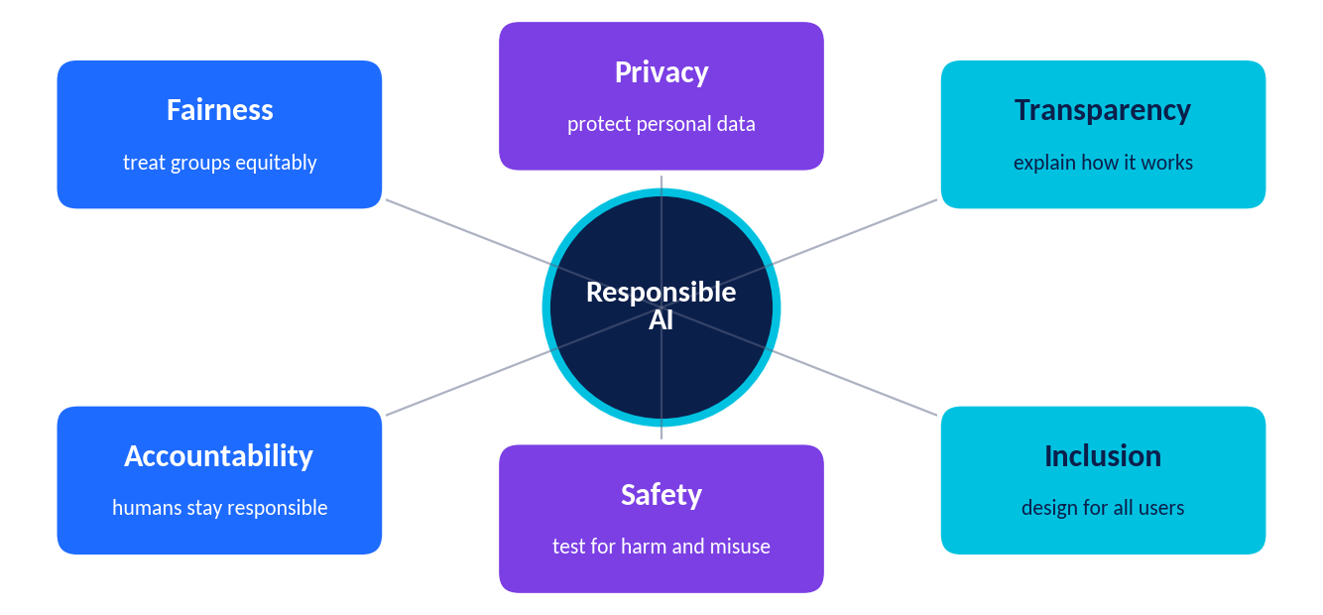
Figure 5.1 Six common principles of responsible AI.
Principle | Question to ask | Example
Fairness | Does it work well for different groups of people? | A face-recognition system must be tested on many skin tones, ages and lighting conditions.
Privacy | Are we protecting personal data? | A school app should collect only the data it needs and keep it secure.
Transparency | Can we explain how and why it gives answers? | Telling users that a response was generated by AI and listing its limits.
Accountability | Who is responsible if something goes wrong? | A named team reviews complaints and corrects errors.
Safety | Have we tested for harm and misuse? | Testing a medical tool in many situations before using it with patients.
Inclusion | Can everyone use it, including people with disabilities or different languages? | Adding voice support and regional languages.

Real-life example: bias in data
Imagine a model trained mostly on scans from one type of hospital machine. It may perform worse on scans from older machines. A responsible team tests across different machines and groups, collects more diverse data, tells users about limits, and keeps a human expert in the loop.

Worksheet 1: Career Exploration – AI Roles
Name: ____________________________ Class/Section: ____ Date: ________
Instructions: Answer all 12 questions. Use Chapters 1 and 2. Write in complete sentences where asked.
1. List three differences between a Data Analyst and a Data Scientist.

2. A school wants to use AI to help decide which students get a scholarship. Which two roles should review the system, and why?

3. Complete the table with one real-world application for each role.
Role | One real-world application
Computer Vision Engineer
NLP Engineer
Robotics Engineer
MLOps Engineer

4. Explain why the job title “Prompt Engineer” may change in the future. Is this a ● TODAY fact or a ◆ FUTURE possibility? Justify your answer.

5. Which role acts as a bridge between users and engineers? Describe two duties of this role.

6. Compare a Robotics Engineer and a Computer Vision Engineer. Where do their jobs overlap?

7. In the AI project pipeline (Figure 1.2), at which stage does an MLOps Engineer matter most? Give a reason.

8. Name an AI-related career that needs less coding than others. What skills does it rely on instead?

9. Why do research roles usually ask for advanced degrees? Suggest one other way a person might contribute to AI research.

10. Choose one role from Chapter 2. List three skills you already have and three skills to develop.

11. Write a 50–60 word job advertisement for an AI Ethics Specialist at a school-technology company.

12. Which role in this chapter would you most like to learn more about? Write two questions you would ask a person who works in it.

Worksheet 2: Career Exploration – Skills and Industries
Name: ____________________________ Class/Section: ____ Date: ________
Instructions: Use Chapters 3 and 4. Show your working for the calculation questions.
1. Read the Python code. What is printed? Write the exact output.
marks = [10, 20, 30, 40]
print(sum(marks) / len(marks))
print([m for m in marks if m > 25])

2. Data set: 2, 3, 3, 4, 48. Calculate the mean and median. Which is a better measure of a “typical” value? Why?

3. Explain the difference between correlation and causation with an example of your own.

4. Match each soft skill to the situation by writing the skill name: *(Communication, Creativity, Teamwork, Critical thinking, Problem-solving)*
Situation | Soft skill
Explaining model results to a hospital manager in plain language
Checking whether a dataset leaves out an important group
Inventing a new way to use sensor data for a school garden
Splitting a bug into smaller parts and testing each part
Agreeing roles and deadlines with project partners

5. Choose one industry from Chapter 4. Describe an AI tool used there ● TODAY and name two careers involved.

6. List three types of data an AI crop-advice app might need and say why each is useful.

7. Why should humans remain involved when AI is used in healthcare?

8. Give two risks of using AI to screen job applications and one way to reduce each risk.

9. Design an AI feature that could help students in your school. Mention one benefit and one risk.

10. List three kinds of jobs in a team that builds driver-assistance features for vehicles.

11. Name two ● TODAY uses of AI in business and one ◆ FUTURE possibility, labelling each clearly.

12. Rate yourself 1–5 on each soft skill and give evidence for your highest score.



Part B · Create Your Career Blueprint
Topic 2 of Unit 4: turn what you have learned into a personal plan for learning, projects, experience and growth.

Chapter 6: Learning Pathways, Portfolios and Experience

6.1 A typical learning pathway
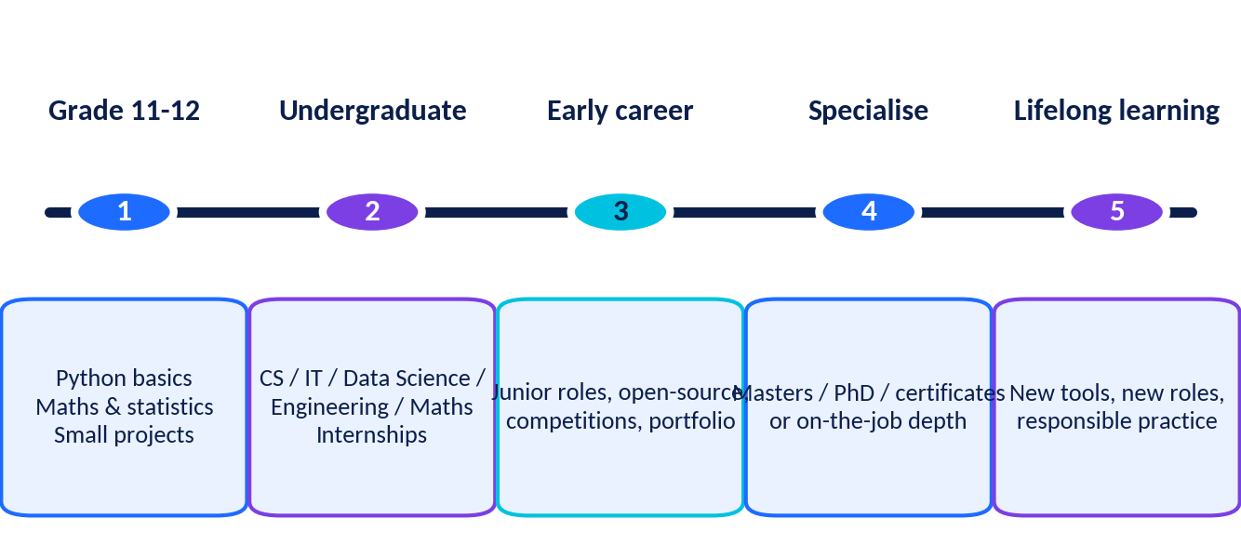
Figure 6.1 A typical pathway. Real journeys vary: many people change direction, pause or learn in different orders.
Stage | Focus | Examples of what you might do
Grade 11–12 | Foundations | Choose subjects that keep options open (maths, computer science/informatics, physics, statistics, languages, economics, as available). Learn Python basics. Start a small project.
After school | Degree or training | Programmes such as B.Tech/B.E., B.Sc. (Computer Science, Data Science, Statistics, Maths), BCA, or related courses. Names and entrance requirements differ by country and university.
During study | Depth + experience | Internships, research projects, hackathons, open-source contributions, clubs and competitions.
Early career | Apply and specialise | Junior roles (analyst, developer, assistant researcher); mentors; a growing portfolio.
Later | Grow | Master’s degree or PhD for some paths, certificates, leadership, switching domains. Learning never stops.
Table 6.1 Always confirm eligibility and course details with official school, board or university sources.

6.2 AI-related courses and learning resources
Many good learning resources exist online, some free and some paid. Content, prices and certificates change, so check the current website before you commit.
Level |  | What to learn | Example places to look
Start |  | Python basics; spreadsheets; basic statistics; “what is AI?” overview courses. | Kaggle Learn, Khan Academy, freeCodeCamp, school coding clubs, beginner courses on Coursera or edX.
Build |  | Data analysis with pandas; machine-learning fundamentals; visualisation; SQL. | Kaggle notebooks, Google’s Machine Learning Crash Course, DeepLearning.AI short courses, NPTEL/SWAYAM (India).
Deepen |  | Deep learning; computer vision or NLP; maths for ML; software engineering. | fast.ai, university open courseware, Hugging Face learning resources, Coursera/edX specialisations.
Apply |  | Projects, competitions, research and real-world data. | Kaggle competitions, hackathons, science fairs, open-source projects, NGO data projects.
Certificates: helpful, but not magic
A certificate can show that you completed a course. It does not guarantee a job. Employers and colleges usually also look at what you can actually do, so combine courses with projects.

6.3 Portfolio development
A portfolio is a collection of projects that shows what you can do. For AI, it often lives on a code-sharing site (such as GitHub) or a simple web page. Each project should tell a story: the problem, the data, the method, the result and what you learned.
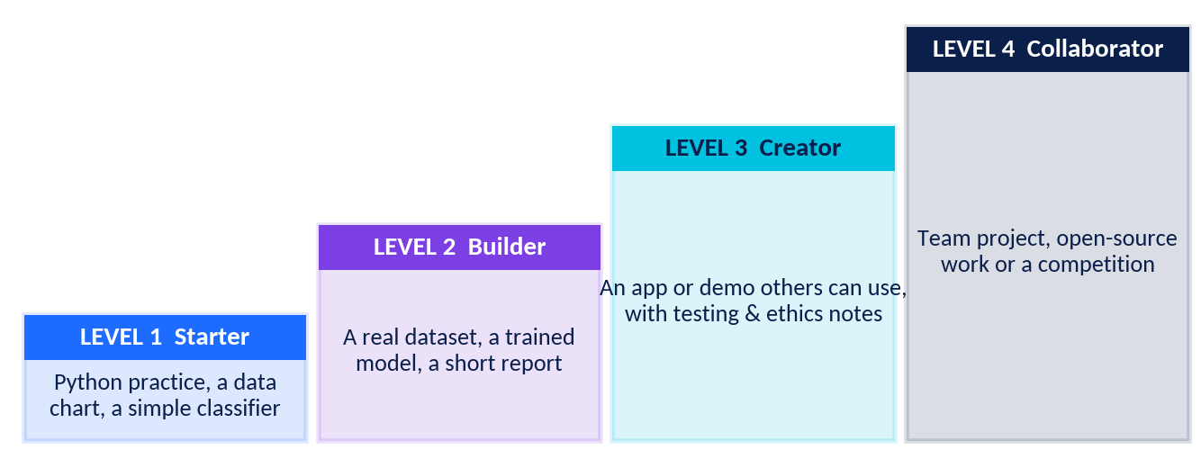
Figure 6.2 Grow your portfolio step by step.
A strong project README includes
- Title and one-sentence goal – what problem did you tackle?
- Data – where it came from, how you cleaned it, and any privacy or permission notes.
- Method – the steps and tools you used, in simple language.
- Results – charts or numbers, and an honest description of limits and mistakes.
- Ethics note – who could be affected, and how you reduced the risk of harm.
- How to run it – so a reader can try your work.
Project ideas for Grade 11 students
Level | Project idea | Skills practised
1 | Analyse a class survey (with permission and no names) and make three clear charts. | Spreadsheets, charts, statistics
1 | Python program that cleans a list of marks and reports mean, median and outliers. | Python, statistics
2 | Train a simple classifier to detect spam in short messages using a public dataset. | ML, evaluation
2 | Predict exam scores from study hours using a small, anonymised or open dataset. | Regression, data ethics
3 | Build a school-FAQ chatbot that gives sources and says “I don’t know” when unsure. | NLP basics, testing, honesty
3 | Local air-quality or rainfall dashboard from open government data. | Data cleaning, visualisation
4 | Team project: fairness check of a public dataset, with a report on risks and fixes. | Teamwork, ethics, writing

6.4 Internships and project experience
An internship is a short period of supervised work or training, usually during or after study, that gives you real-world experience. For school students, formal internships are less common, but there are many related options:
- School and community: coding clubs, science exhibitions, volunteering to analyse data for a local NGO or school project.
- Competitions: hackathons, AI or data olympiads, and beginner-friendly online competitions.
- University outreach: open days, summer schools and workshops for school students (check eligibility and dates).
- Open-source: fixing documentation or small issues in public projects, with a mentor’s guidance.
- Mentors: teachers, relatives, alumni or professionals who can review your work.
Stay safe when looking for opportunities
• Be careful with offers that ask for upfront fees, guarantee a job, or pressure you to decide immediately.
• Check the organisation’s website and ask your teacher or parent/guardian to help verify it.
• Never share passwords, ID documents or private data unless an adult confirms it is safe.
• Follow age and legal rules for work and online accounts.
Sample outreach message (edit and personalise)
Dear Dr. Rao, I am a Grade 11 student who enjoys data and coding. I built a small project that analyses local rainfall data (link attached). Could you suggest one way I could improve it, or a beginner resource you recommend? Thank you for your time. – Name, School

Chapter 7: Know Yourself, Set Goals, Build Your Roadmap
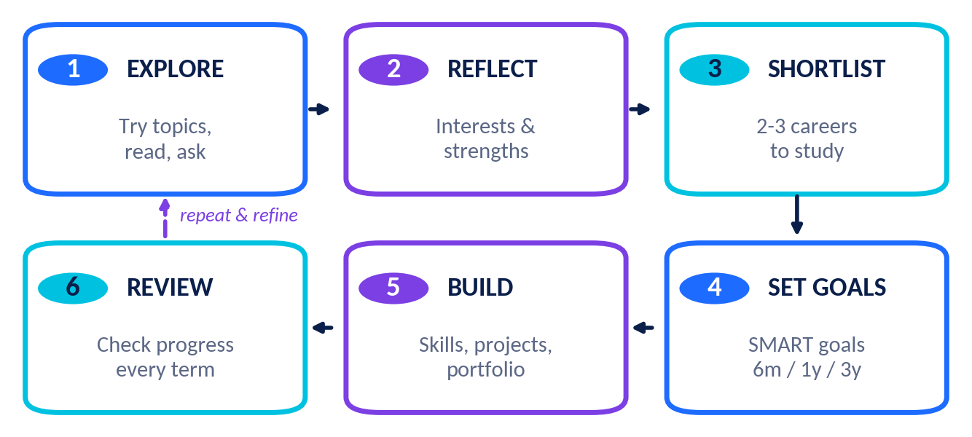
Figure 7.1 The six-step Career Blueprint cycle.

7.1 Explore your interests
Interests change, and that is normal. A helpful framework is Holland’s six interest types (RIASEC), widely used in career guidance. Most people are a mix of two or three.
Type | You may enjoy… | Example AI-related careers
Realistic | Building, tools, machines, outdoors | Robotics Engineer, MLOps Engineer
Investigative | Puzzles, science, data, research | Data Scientist, AI Researcher
Artistic | Design, writing, imagination | Prompt Engineer, Conversational Designer
Social | Helping, teaching, listening | AI Educator, AI Ethics Specialist
Enterprising | Leading, persuading, starting things | AI Product Manager
Conventional | Organising, accuracy, systems | Data Analyst, Data Engineer
Table 7.1 Interest types are a starting point for reflection, not a test that decides your future.

7.2 Identify your strengths
A strength is something you are good at, enjoy and can show evidence for. Collect evidence from school work, hobbies, clubs and feedback from teachers and friends. Rate your skills from 1 (just starting) to 5 (confident) and plot them on a radar chart. Riya’s chart is below; she is creative and communicates well, and she wants to grow in Python.
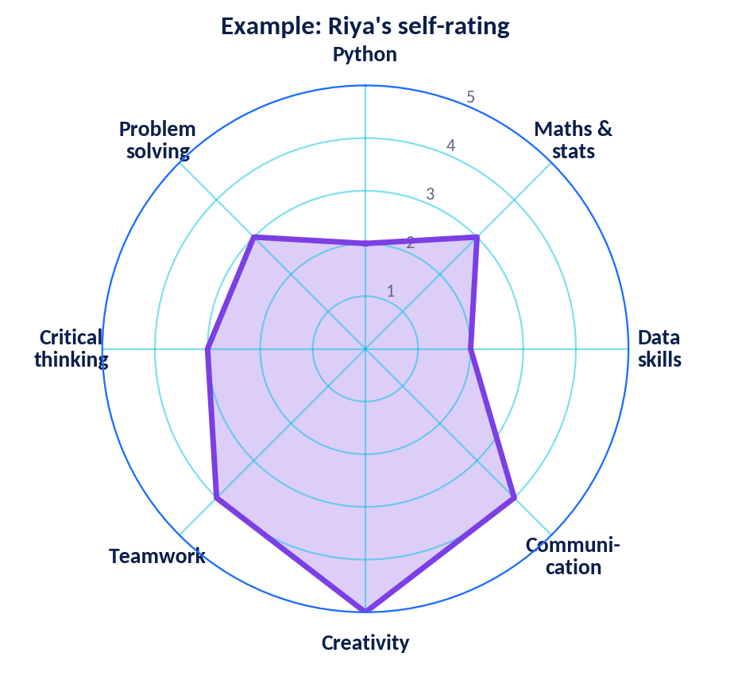

7.3 Set SMART goals
Letter | Meaning | Example
S | Specific – exactly what you will do | Learn Python basics and build two small data projects.
M | Measurable – how you will know | Finish a 20-lesson course and publish two projects with README files.
A | Achievable – realistic with your time and resources | Study 4 hours per week using a school computer or library.
R | Relevant – connected to your bigger aim | Supports my aim of becoming a data scientist or ML engineer.
T | Time-bound – a deadline | Complete both by 31 March.
Set goals for three time horizons: 6 months (skills and habits), 1–2 years (courses, projects, exams) and 3–5 years (education route and experience). Goals can change; what matters is a clear next step.

7.4 Compare options with a decision matrix
When two or three careers look attractive, score them. Give each criterion a weight (1–5, how important it is to you) and each career a score (1–5). Multiply and add.
Criterion | Weight | Career A: Data Scientist (score × weight) | Career B: Product Manager (score × weight)
I enjoy this work | 5 | 4 × 5 = 20 | 5 × 5 = 25
It matches my strengths | 4 | 3 × 4 = 12 | 2 × 4 = 8
It helps others or society | 3 | 5 × 3 = 15 | 3 × 3 = 9
The learning path is clear | 2 | 3 × 2 = 6 | 4 × 2 = 8
Total |  | 53 | 50
The totals (53 and 50) are close, so the student should explore both with a mentor and a small project before deciding. A matrix supports thinking; it does not replace it.

7.5 Build your roadmap
- Explore: talk to people, try beginner projects, read about careers.
- Reflect: record interests, strengths and values.
- Shortlist: choose two or three careers to study in depth.
- Set goals: write SMART goals for 6 months, 1 year and 3 years.
- Build: learn skills, make projects, find experiences, and keep a portfolio.
- Review: every term, check progress, adjust and celebrate small wins. Prepare a Plan B and a Plan C.

Worksheet 3: Career Exploration – Pathways and Responsible AI
Name: ____________________________ Class/Section: ____ Date: ________
Instructions: Use Chapters 5, 6 and 7. Be honest and specific.
1. List three actions you can take this year to begin your AI learning pathway.

2. What is a portfolio? Give two reasons why it can help when applying for courses or internships.

3. “A certificate alone guarantees a job.” Do you agree or disagree? Explain.

4. Name three learning resources or platforms and say what you would study with each.

5. Describe a Level 2 portfolio project you would like to do. Name the data you would use and one ethical issue to consider.

6. List four items that should appear in a project README.

7. Write three warning signs of a fake or unsafe internship offer.

8. Make a 4-week learning plan. Fill in one goal for each week.
Week | My learning goal | Hours
1
2
3
4

9. What is bias in data? Give one example and one way to reduce it.

10. If an AI system makes a harmful decision, who should be accountable? Discuss.

11. List three habits of a lifelong learner and say how you will practise one of them.

12. Choose one career you are exploring. Write one benefit and one challenge of that career.

Worksheet 4: Career-Interest Self-Reflection
Name: ____________________________ Class/Section: ____ Date: ________
Part A – What do I enjoy? (Circle 1 = not at all … 5 = love it)
Activity | 1 2 3 4 5 | May link to (type / careers)
Solving logic puzzles or maths problems | 1 2 3 4 5 | Investigative / Data Scientist, Researcher
Building or fixing things with my hands | 1 2 3 4 5 | Realistic / Robotics Engineer
Designing posters, videos or stories | 1 2 3 4 5 | Artistic / Prompt Engineer, Designer
Explaining ideas so others understand | 1 2 3 4 5 | Social / Educator, Analyst
Leading a team or organising an event | 1 2 3 4 5 | Enterprising / Product Manager
Keeping data, files or schedules tidy | 1 2 3 4 5 | Conventional / Data Analyst
Writing code and seeing it run | 1 2 3 4 5 | Realistic–Investigative / AI Engineer
Debating right and wrong | 1 2 3 4 5 | Social–Investigative / Ethics Specialist
Finding patterns in numbers or charts | 1 2 3 4 5 | Investigative / Data Analyst
Learning how living things work | 1 2 3 4 5 | Investigative / Health-AI Scientist
Working with sensors, circuits or machines | 1 2 3 4 5 | Realistic / Robotics, MLOps
Learning new languages or how language works | 1 2 3 4 5 | Artistic–Investigative / NLP Engineer
Part B – My top three interest types
Circle three: Realistic · Investigative · Artistic · Social · Enterprising · Conventional
Part C – Reflection questions
1. Which activities gave me energy, and which tired me? Why do I think so?

2. Think of a time I lost track of time while working. What was I doing?

3. What problem in my school, family or community would I most like to help solve?

4. Which two careers from this unit seem most interesting right now? What attracts me to each?

5. What worries me about a career in AI or technology? Who could I talk to about it?

6. What do my teachers, family or friends say I am good at? Do I agree?

7. Complete: “Five years from now, I hope to be learning about / working on …”

8. Which of my interests might I not have discovered yet? How can I try something new this month?

Worksheet 5: Personal Skills Assessment and Goal-Setting
Name: ____________________________ Class/Section: ____ Date: ________
Step 1 – Rate your current skills (1 = beginner, 5 = confident) and add evidence
Skill | Rating (1–5) | Evidence (project, marks, activity) | Next step to improve
Python / programming
Mathematics
Statistics & data handling
Machine-learning ideas
Using AI and data tools
Communication
Creativity
Teamwork
Critical thinking
Problem-solving

Step 2 – Plot your radar
Group your ratings into the 8 axes (average where needed), mark each score on its axis, and join the dots.
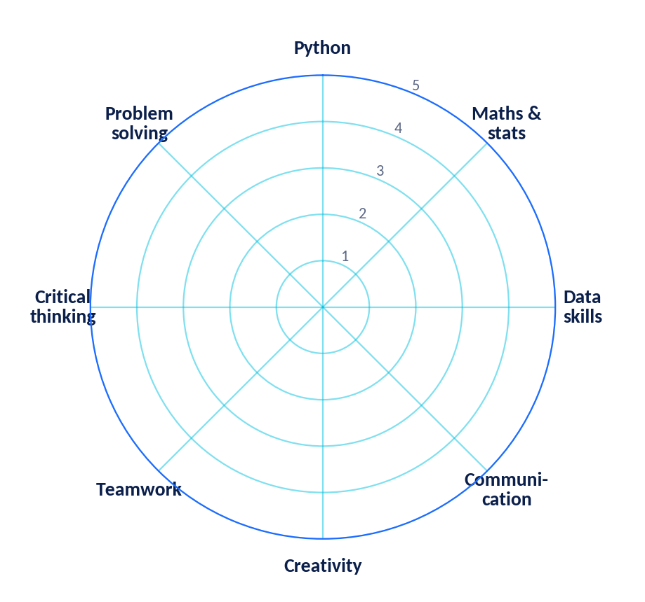
Step 3 – Reflect
1. My three strongest skills are … and my three biggest growth areas are …

2. Which growth area matters most for the career I am exploring, and why?

Step 4 – Write SMART goals
Time frame | Specific goal | Measure of success | Deadline
6 months
1–2 years
3–5 years

Step 5 – Weekly plan, obstacles and support
My weekly time for learning | Possible obstacles | People and resources that can help

Worksheet 6: My AI Career Blueprint (Step-by-Step Template)
Complete each step in order. Use your earlier worksheets. Your blueprint is a living document: revise it every term. It is a plan to guide you, not a promise of any outcome.
STEP 1 | My snapshot
Name and grade
Subjects I am studying
Activities, clubs, hobbies
My main values (what matters to me)

STEP 2 | Interests and strengths (from Worksheets 4 and 5)
My top 3 interests |  | My top 3 strengths | Skills I want to build

STEP 3 | Career shortlist – explore 3 careers
Career |  | Why it interests me | What it typically requires | Questions / worries

STEP 4 | Decision matrix (weights 1–5 × scores 1–5)
Criterion |  | Weight | Career 1 score × weight | Career 2 score × weight | Career 3 score × weight
I enjoy this work
Matches my strengths
Helps people or society
Learning path is clear
Other (my own): ______
TOTAL

STEP 5 | Skills gap analysis for my first-choice career
Skill needed |  | My level now (1–5) | Target level | How I will improve it | By when

STEP 6 | Learning pathway – year by year
Time |  | Education / courses | Projects & portfolio | Experience (club, internship, competition)
Grade 11
Grade 12
Years 1–2 after school
Years 3–4+

STEP 7 | SMART goals and milestones
Goal (specific & measurable) |  | Deadline | First action this week

STEP 8 | Risks, Plan B and responsible-AI commitments
What could go wrong? |  | My Plan B / Plan C | My responsible-AI promises (e.g. honesty, privacy, fairness)

STEP 9 | Support network and review schedule
People who can guide me (teacher, family, mentor)
Resources I will use (courses, books, clubs)
I will review this blueprint on (dates)
Signature and date

Case Studies: People in AI-Related Careers
About these case studies
The two people below are fictional composite characters created from typical career paths so that you can study realistic situations. Real people’s journeys vary widely and are not guaranteed to match.

Case Study 1: Meera – Machine Learning Engineer in healthcare imaging
Background | A typical day
In Grade 11 Meera liked maths and biology and joined a coding club, where she wrote small Python programs. She studied Computer Science in college, completed an internship at a health-technology start-up, and joined as a junior ML engineer. | Reads new data and model results; trains and tests models that help highlight possible problem areas in scans; discusses results with doctors; documents experiments; attends weekly team meetings.

Challenge: Meera’s team noticed the model was less accurate on images from older scanning machines. Instead of ignoring the problem, they collected more varied images, tested the model on each machine type, told doctors about the limitation, and kept a doctor’s review as the final step.
Skills used: Python, statistics, deep learning, communication with doctors, critical thinking, responsible AI.
Lessons: Strong technical skills matter, but so do listening, teamwork and honesty about limits.
Questions
1. List three technical and two soft skills Meera uses. Which would you like to build first?

2. Why did the team test the model separately on each machine type?

3. Why is a doctor’s review still important even if the model is accurate?

4. What early steps in Meera’s story could you copy during Grade 11–12?

Case Study 2: Arjun – AI Ethics Specialist at an education-technology company
Background | A typical day
Arjun enjoyed debate and social studies in school and took an introductory data-science elective. He studied public policy with a data minor, later joined a company that builds AI tutoring tools, and now leads its responsible-AI reviews. | Reviews new features for risks; designs tests across languages and regions; writes plain-language guidelines about student data; listens to teachers and parents; reports findings to product and engineering teams.

Challenge: During testing, Arjun’s team found the AI tutor gave less helpful explanations for questions written in one regional language. The launch was delayed. Engineers added better training data, local teachers reviewed the output, and the tutor was released with clear notes about its limits.
Skills used: Critical thinking, communication, ethics and law basics, data literacy, empathy, teamwork.
Lessons: Not every AI career starts with advanced programming. Asking the right questions can prevent harm and improve products.
Questions
1. Which principle(s) of responsible AI (Figure 5.1) did the regional-language problem involve?

2. Do you agree with delaying the launch? Give reasons for and against.

3. Compare Arjun’s and Meera’s educational paths. What is different and what is similar?

4. Write two questions you would ask Arjun in an interview.

Mini-Project: Design Your Personal AI Career Roadmap
Goal: Create a clear, visual, one-page roadmap for the next 5–7 years that shows how you could move towards an AI-related career that interests you, while staying flexible.
What you will submit
- Roadmap poster or slide (one page, A3 poster, a Word/PowerPoint page or a hand-drawn chart).
- Reflection of about 250–300 words: why this path, what could change, how you will use AI responsibly.
- Two-minute presentation to the class or a family member, ending with one question from the audience.
Project steps
Week | Task | Evidence
1 | Complete Worksheets 4, 5 and 6 (interests, skills, blueprint). | Filled worksheets
2 | Research two careers using at least three reliable sources; interview one person if possible. | Source list, interview notes
3 | Draw the roadmap using the grid below; add one SMART goal for each time block. | Draft roadmap
4 | Get feedback from a teacher or mentor, revise, and present. | Final roadmap, reflection, feedback note
Roadmap grid (plan here first, then design your final version)
 | Now – Grade 12 | Years 1–2 after school | Years 3–4 | Years 5–7
Learn
Build (projects)
Experience
People & mentors
Responsible AI
Plan B

Assessment rubric for the mini-project (20 marks)
Criterion |  | Excellent (4) | Good (3) | Developing (2) | Beginning (1)
Self-knowledge – interests, strengths, evidence |  | Detailed, evidence-based | Clear with some evidence | General statements | Little reflection
Career research – accuracy, sources |  | 3+ reliable sources, accurate | 2–3 sources, mostly accurate | 1 source or some errors | Little or inaccurate
Roadmap quality – SMART goals, realism |  | All blocks complete, SMART, realistic | Mostly complete | Several gaps | Incomplete
Responsible AI & Plan B |  | Specific commitments and flexible alternatives | Clear but general | Brief mention | Missing
Presentation & design – clarity, creativity |  | Clear, engaging, well designed | Clear and tidy | Hard to follow in parts | Unclear
Honesty note
You may use AI tools to brainstorm or check grammar if your teacher allows it, but the ideas, choices and reflection must be yours. Mention any tool you used.


Part C · Practice, Revision and Assessment
Check your learning with a range of question types, activities, puzzles and a 30-mark unit assessment.

Practice Questions
Name: ____________________________ Class/Section: ____ Date: ________

Section 1: Multiple-choice questions (30 × 1 mark)
Choose the one best answer and circle its letter. Answers are in the Answer Key.
1. Which role mainly decides what AI product to build and why, balancing user needs, business goals and technical limits?
(A) Robotics Engineer | (B) AI Product Manager
(C) Data Annotator | (D) MLOps Engineer
2. A Data Scientist most commonly…
(A) designs robot arms | (B) prepares legal contracts
(C) uses data and statistics to find insights and build models | (D) repairs computer networks
3. Which programming language is most widely used by beginners in AI and machine learning?
(A) Python | (B) HTML only
(C) Assembly | (D) Cobol
4. Which of these is the best example of AI augmenting (assisting) a job?
(A) A robot replaces a whole hospital | (B) A doctor uses AI to highlight areas on a scan, then makes the final decision
(C) A website deletes all its human staff | (D) A student copies an answer without reading it
5. An MLOps Engineer mainly…
(A) paints user-interface icons | (B) writes laws about AI
(C) deploys, monitors and maintains ML systems | (D) teaches maths to beginners
6. An AI Researcher typically focuses on…
(A) selling AI products | (B) developing and testing new methods and algorithms
(C) repairing phones | (D) drawing logos
7. Which skill helps most when explaining a model’s results to non-technical people?
(A) Communication | (B) Typing speed
(C) Memorising code | (D) Colour theory only
8. Which measure is least affected by extreme outliers?
(A) Mean | (B) Total
(C) Median | (D) Maximum
9. “Correlation does not imply causation” means…
(A) two things that move together are always caused by each other | (B) two things may move together without one causing the other
(C) data is never useful | (D) only large datasets matter
10. Which responsible-AI principle asks whether a system treats different groups of people equitably?
(A) Fairness | (B) Speed
(C) Storage | (D) Popularity
11. Which is a ● TODAY use of AI in agriculture?
(A) Fully automatic farms with no people anywhere | (B) Phone apps that help identify crop diseases from leaf photos
(C) Predicting every harvest perfectly | (D) Replacing all weather forecasts
12. A portfolio is best described as…
(A) a list of your friends | (B) a collection of projects that shows your skills
(C) a type of computer chip | (D) a government licence
13. In the Career Blueprint cycle, the first step is to…
(A) apply for senior jobs | (B) explore interests and options
(C) buy a laptop | (D) finish a PhD
14. In SMART goals, the letter M stands for…
(A) Memorised | (B) Maximum
(C) Measurable | (D) Mandatory
15. Which is the best SMART goal?
(A) “Learn AI someday.” | (B) “Be the best.”
(C) “Complete a beginner Python course and publish two small projects by 31 March.” | (D) “Study more.”
16. Computer vision engineers mainly work with…
(A) images and video | (B) only audio files
(C) only spreadsheets | (D) handwritten letters only
17. NLP engineers mainly work with…
(A) electric motors | (B) human language in text and speech
(C) bridges and roads | (D) musical instruments only
18. Why is lifelong learning important in AI careers?
(A) Tools and methods change quickly | (B) Learning is illegal after school
(C) AI never changes | (D) Only managers need to learn
19. Which is a warning sign of a fake internship?
(A) A clear description of tasks | (B) A request for upfront payment with a guaranteed job
(C) A verified company website | (D) A named supervisor
20. A robotics engineer commonly combines programming with…
(A) electronics and mechanics | (B) only poetry
(C) only accounting | (D) only history
21. An AI Ethics Specialist might…
(A) audit a job-screening tool for biased results | (B) only tune guitar strings
(C) avoid talking to users | (D) delete all data
22. Overfitting happens when a model…
(A) learns training data too closely and performs poorly on new data | (B) is too simple to run
(C) has no data | (D) is always 100% accurate
23. Which statement about AI and jobs is most accurate?
(A) AI will remove every job next year | (B) AI will change nothing
(C) AI changes many jobs by automating some tasks and creating others; the exact future impact is uncertain | (D) Only programmers are affected
24. In supervised learning, the training data contains…
(A) no examples | (B) labelled examples
(C) only music | (D) only random numbers
25. Which tool is commonly used to share and track code projects online?
(A) GitHub | (B) A calculator
(C) A projector | (D) A printer
26. A prompt engineer mainly…
(A) designs and tests instructions for generative AI systems | (B) builds bridges
(C) sells hardware | (D) prints textbooks
27. Which of the following is a soft skill?
(A) Teamwork | (B) Python syntax
(C) Matrix multiplication | (D) SQL queries
28. Data cleaning means…
(A) deleting all data | (B) fixing errors, missing values and inconsistencies in data
(C) wiping the computer screen | (D) encrypting data only
29. Which statement about education pathways to AI careers is best?
(A) There is only one correct route | (B) Multiple routes exist and requirements vary by role and employer
(C) No education is ever useful | (D) Only one country offers AI courses
30. A hospital tool performs worse for one group of patients. What is the best first response?
(A) Hide the result | (B) Investigate the data and testing, involve experts, and improve the system
(C) Ignore it because the average is good | (D) Blame the patients

Section 2: Fill in the blanks (12 × 1 mark)
Word bank
portfolio · MLOps · Python · bias · median · internship · supervised · Specific · Computer · lifelong · prompt · transparency

1. A __________ is a collection of projects that shows what you can do.
2. The __________ engineer keeps ML systems reliable after they are launched.
3. ________ is a popular programming language for AI beginner
4. When data unfairly favours one group, it contains __________.
5. The __________ is the middle value of an ordered data set.
6. A short supervised work placement that gives experience is an __________.
7. In __________ learning, a model learns from labelled examples.
8. In SMART goals, S stands for __________.
9. ________ vision is the field that helps computers interpret image
10. Continuing to learn throughout life is called __________ learning.
11. An instruction given to a generative AI system is called a __________.
12. Explaining how an AI system works and where its limits are supports __________.

Section 3: Match the following
Set A – Match each career with its main role. Write the letter.
No. | Career | Answer | Letter | Main role
1 | Data Analyst |  | A | Decides what to build and why, linking users and engineers
2 | Robotics Engineer |  | B | Checks AI systems for fairness, privacy and safety
3 | AI Researcher |  | C | Builds dashboards and reports from data to support decisions
4 | AI Product Manager |  | D | Monitors and maintains models after deployment
5 | AI Ethics Specialist |  | E | Develops and tests new algorithms and methods
6 | MLOps Engineer |  | F | Designs and tests instructions for generative AI
7 | Prompt Engineer |  | G | Teaches machines to interpret images and video
8 | Computer Vision Engineer |  | H | Designs machines that sense, decide and act

Set B – Match each industry with an example of AI use.
No. | Industry | Answer | Letter | Example use
1 | Healthcare |  | A | Analyses camera-trap images to count wildlife
2 | Agriculture |  | B | Supports doctors in reading medical scans
3 | Education |  | C | Forecasts demand for products
4 | Transportation |  | D | Predicts traffic and plans efficient routes
5 | Business |  | E | Adapts practice questions to a learner’s level
6 | Environment |  | F | Identifies crop disease from leaf photos

Section 4: True or false (12 × 1 mark)
Write T or F. For every false statement, rewrite it correctly.
No. | Statement | T / F | Correction (if false)
1 | All AI careers require a PhD.
2 | Data analysts and data scientists never share any skills.
3 | Soft skills are valuable in AI careers.
4 | A strong portfolio can show practical skills even before you have a long work history.
5 | If two variables are correlated, one must cause the other.
6 | Choosing an AI career guarantees a high salary.
7 | Responsible AI includes thinking about privacy and fairness.
8 | “Prompt Engineer” is a settled job title that will never change.
9 | Learning ends once you finish a degree in AI.
10 | Robotics engineers may combine software with hardware.
11 | The median is more affected by outliers than the mean.
12 | Internship offers that demand upfront fees and promise guaranteed jobs deserve extra caution.

Section 5: Short-answer questions (8 questions)
1. Distinguish between an AI Engineer and a Machine Learning Engineer.

2. Why are soft skills important for AI professionals?

3. Explain why AI is said to change tasks as well as jobs.

4. Describe two ways to build a portfolio as a school student.

5. State one benefit and one challenge of an AI career.

6. What is a SMART goal? Give one example.

7. How might AI help agriculture, and which careers are involved?

8. Why does ethics matter for engineers who build AI?

Classroom Activities

Activity 1: Career Speed-Networking
Time / group | 25 minutes · Pairs rotating in two circles
Materials | Role cards (12 careers), timer, notepaper
Objective | Practise explaining a role and asking good career questions.
Steps | 1. Each student receives a role card (e.g. Data Analyst, Robotics Engineer, AI Ethics Specialist) and reads the profile in Chapter 2 for 3 minutes.  2. Students form an inner and outer circle. The inner student plays the professional; the outer student is the visitor.  3. For 2 minutes the visitor asks questions (What do you do? Which skills? How did you start?). Then roles swap.  4. The outer circle moves one place clockwise. Repeat 4–5 rounds.
Reflect | Which role surprised you most? Which role would you like to learn more about, and why?

My notes / reflection:

Activity 2: The AI Pipeline Human Chain
Time / group | 20 minutes · Five groups
Materials | Problem cards (e.g. “predict bus delays”), five stage signs, markers
Objective | See how different roles work together across an AI project.
Steps | 1. Each group is assigned a stage from Figure 1.2 and writes the tasks and roles needed at that stage for the problem card.  2. Groups stand in pipeline order. A student carries the problem card from stage to stage while each group explains its contribution in 30 seconds.  3. Class discusses: Where could bias or mistakes enter? Who would notice?
Reflect | Which stage would you choose to work on, and which soft skills would you need?

My notes / reflection:

Activity 3: The Skill Auction
Time / group | 25 minutes · Teams of 4
Materials | 100 play-money points per team, list of 12 skills, project card
Objective | Prioritise technical and soft skills for a real project.
Steps | 1. Each team receives the project “Build a plant-disease app for farmers”.  2. Teams bid points on skills (Python, statistics, communication, ethics, UX design, teamwork, creativity, domain knowledge, etc.). They must spend all 100 points.  3. Teams reveal their top three skills and justify them. The class compares choices.
Reflect | Did any team ignore a skill that others considered essential? What does that teach you about teamwork?

My notes / reflection:

Activity 4: Structured Debate – “AI will change jobs more than it will remove them”
Time / group | 30 minutes · Two sides + judges
Materials | Evidence cards, timer, scoring sheet
Objective | Practise critical thinking, evidence use and respectful discussion.
Steps | 1. Teams prepare for 8 minutes using Chapters 1 and 5. Every claim must be labelled ● TODAY (evidence) or ◆ FUTURE (prediction).  2. Opening statements (2 minutes each), rebuttals (2 minutes each), questions from judges.  3. Judges score on evidence, clarity and respect, not on personal opinions. Students then switch sides mentally and write one point for the other team.
Reflect | Which argument changed your mind or made you more careful? Which claims were only predictions?

My notes / reflection:

Activity 5: Career Roadmap Gallery Walk
Time / group | 30 minutes · Whole class
Materials | Roadmap posters or pages, sticky notes (3 colours)
Objective | Give and receive constructive feedback on career plans.
Steps | 1. Display mini-project roadmaps around the room.  2. Students walk in pairs and leave sticky notes: green = “I like…”, yellow = “I wonder…”, blue = “I suggest…”.  3. Return to your own roadmap, read the notes and write two improvements.
Reflect | What one suggestion will you act on this month?

My notes / reflection:

Puzzles and Challenges

Puzzle 1: AI Career Word Search
Find the 12 hidden words. They may run across, down, diagonally or backwards (right, left, down, up, down-right).
C | A | R | E | E | R | C | S | Y | D | M | D | J
S | M | C | A | V | A | G | G | E | B | P | M | W
A | M | N | C | S | U | G | Y | T | V | N | I | K
I | C | J | K | A | N | Y | D | H | M | O | E | H
B | W | D | A | B | O | Z | P | I | O | H | F | V
R | G | S | O | Q | G | X | Y | C | D | T | E | N
U | M | L | D | M | N | G | A | S | E | Y | I | Z
O | I | L | O | F | T | R | O | P | L | P | S | J
A | G | I | S | C | I | T | S | I | T | A | T | S
F | M | K | T | U | S | P | R | O | M | P | T | D
B | E | S | G | O | I | N | R | E | T | N | I | A
Y | T | K | J | D | A | T | A | M | C | C | C | G
S | U | H | A | T | L | L | R | O | B | O | T | T

Word list
PYTHON · DATA · MODEL · ETHICS · ROBOT · PROMPT · PORTFOLIO · INTERN · BIAS · SKILLS · CAREER · STATISTICS

Puzzle 2: Decode the Career Titles
Each title below is written in a shift-3 cipher: every letter has been moved 3 places forward in the alphabet (A becomes D, B becomes E, and so on). Shift each letter back by 3 to decode. Spaces are unchanged. Example: D → A.
No. | Coded title | Decoded title
1 | GDWD VFLHQWLVW
2 | URERWLFV HQJLQHHU
3 | SURPSW HQJLQHHU
4 | DL HWKLFV VSHFLDOLVW
5 | SURGXFW PDQDJHU
6 | PDFKLQH OHDUQLQJ

Puzzle 3: Who Has Which Career? (logic)
Four friends, Asha, Bilal, Chen and Divya, each work in a different AI-related career: Robotics Engineer, Data Scientist, AI Ethics Specialist and Prompt Engineer. Use the clues to match each person with a career.
- Asha is neither the Robotics Engineer nor the Data Scientist.
- Bilal is neither the AI Ethics Specialist nor the Prompt Engineer.
- Chen is not the Robotics Engineer, not the AI Ethics Specialist and not the Prompt Engineer.
- Divya is neither the Data Scientist nor the Prompt Engineer.
Person | Robotics Engineer | Data Scientist | AI Ethics Specialist | Prompt Engineer
Asha
Bilal
Chen
Divya
Tip: put a ✗ in boxes that are impossible and a ✓ in the box that is certain. Final answer: Asha = __________ Bilal = ____ Chen = ____ Divya = ______

Puzzle 4: Unscramble the Career Words
Unscramble each word. The hint tells you what it means.
No. | Scrambled | Hint | Your answer
1 | MAILTORGH | a step-by-step set of instructions for solving a problem
2 | ADSTTAE | a collection of data used to train or test a model
3 | POIOFLORT | a collection of your projects that shows what you can do
4 | EITRNPISNH | a short placement that gives real work experience
5 | FNAISSER | a responsible-AI principle: treating groups equitably
6 | HPNYOT | a popular programming language for AI

Bonus challenge
Write a four-line riddle (without naming the career) about any career in this unit. Swap with a partner and see if they can guess it.

Quick Revision Quiz
Answer each question in one line. Time: 8 minutes. (10 marks)
1. Name the five soft skills discussed in Chapter 3.

2. Which statistic is better for data that contains outliers: mean or median?

3. Name the three main types of machine learning.

4. What does the “T” in SMART stand for?

5. Give one ● TODAY example of AI in agriculture.

6. Which role keeps deployed ML systems reliable?

7. Name two things a good project README should contain.

8. What does “lifelong learning” mean?

9. Which responsible-AI principle asks “Who is responsible if something goes wrong?”

10. Name the five families of AI careers in Chapter 1.

Concept Map
A concept map shows how ideas connect. Study the map for Unit 4, then build your own below.
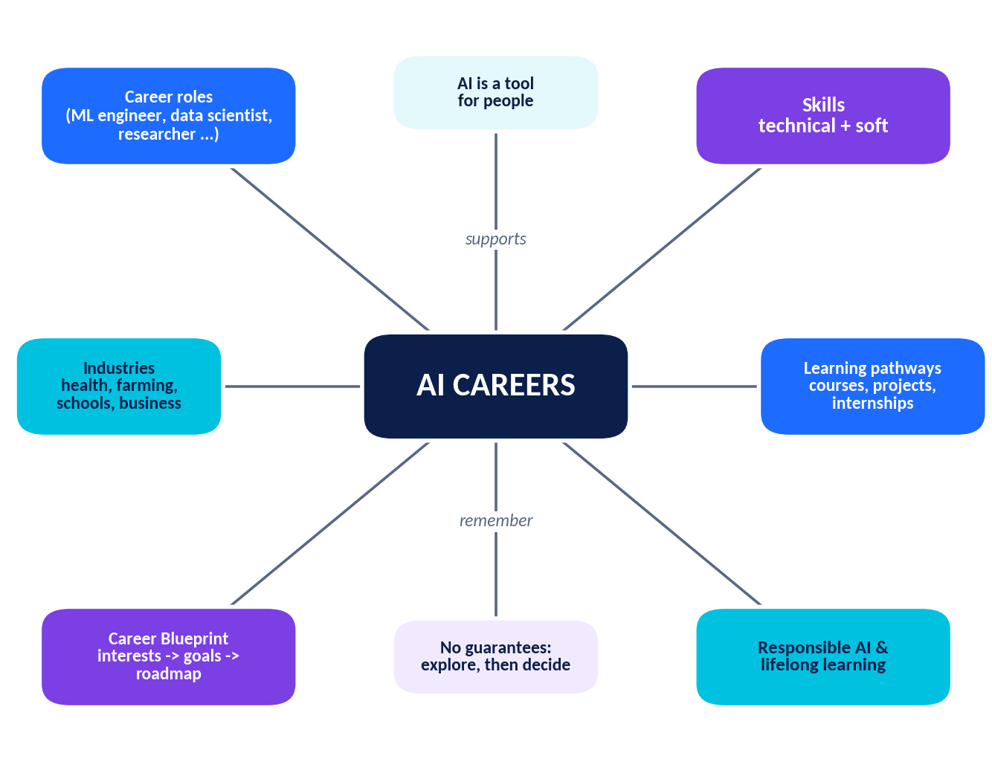
Figure C.1 Concept map for Month 4 – Unit 4: AI & Career.
Your turn: complete a concept map in your own words
MY AI CAREER PLAN
Write one key idea in each outer box (for example: roles, skills, industries, learning pathway, goals, responsible AI, risks).

Chapter Summary
- AI careers include building, analysing, researching, guiding and governing AI; many involve little or no heavy coding.
- Separate [[TODAY]] facts from [[FUTURE]] predictions; AI often changes tasks in a job rather than removing the whole job.
- Key roles: AI Engineer, ML Engineer, Data Scientist, Data Analyst, Robotics Engineer, AI Researcher, Prompt Engineer, AI Product Manager, AI Ethics Specialist, Computer Vision and NLP Engineers, MLOps Engineer.
- Technical skills: Python, mathematics, statistics, data analysis, machine learning and AI tools. Soft skills: communication, creativity, teamwork, critical thinking, problem-solving.
- AI is used in healthcare, education, agriculture, business, transport, environment, media and public services, usually with humans in the loop.
- Pathways combine education, courses, a portfolio, internships/projects and mentors. Certificates help but do not guarantee jobs.
- Know yourself first: explore interests, identify strengths with evidence, then set SMART goals for 6 months, 1–2 years and 3–5 years.
- Build a roadmap, review it every term, and keep a Plan B.
- AI careers bring benefits (meaningful work, variety) and challenges (rapid change, ethical responsibility, uncertainty). No career guarantees a job or salary.
- Lifelong learning and responsible AI (fairness, privacy, transparency, accountability, safety, inclusion) apply to every role.

Glossary
Term | Meaning
Accountability | Making sure people or organisations remain responsible for AI decisions and outcomes.
Algorithm | A step-by-step set of instructions for solving a problem.
Bias (in data) | Patterns in data or models that unfairly favour or disadvantage certain groups.
Career blueprint | A personal plan that links interests, skills, goals, learning and experience.
Computer vision | AI that helps computers understand images and video.
Correlation | A relationship in which two variables tend to change together; it does not prove cause.
Data analysis | Collecting, cleaning, exploring and explaining data to answer questions.
Data cleaning | Fixing errors, missing values and inconsistencies in data.
Dataset | An organised collection of data used for analysis or to train and test models.
Deep learning | ML using multi-layered neural networks, effective for images, speech and language.
Deployment | Putting a model into a real product or system so people can use it.
Generative AI | AI that creates new content such as text, images, audio or code.
Internship | A short period of supervised work or training to gain experience.
Lifelong learning | Continuing to learn new skills throughout life.
Machine learning (ML) | Methods that let computers learn patterns from data instead of following only fixed rules.
MLOps | Practices and tools for deploying, monitoring and maintaining ML systems.
Median | The middle value of an ordered data set; less affected by outliers than the mean.
NLP (natural language processing) | AI that works with human language in text and speech.
Outlier | A value that is very different from most others in a data set.
Overfitting | When a model learns training data too closely and performs poorly on new data.
Portfolio | A collection of projects that demonstrates your skills.
Prompt | An instruction or question given to a generative AI system.
Python | A readable programming language widely used in AI and data science.
Responsible AI | Designing and using AI fairly, safely, transparently and with respect for privacy.
Robotics | The field of designing, building and programming machines that sense and act.
SMART goal | A goal that is Specific, Measurable, Achievable, Relevant and Time-bound.
Soft skills | Personal skills such as communication, teamwork, creativity, critical and problem-solving thinking.
Supervised learning | ML that learns from labelled examples.
Transparency | Being open about how an AI system works, what data it uses and what its limits are.
Unsupervised learning | ML that finds patterns in data without labels.

Unit Assessment (30 Marks)
Month 4 – Unit 4: AI & Career Time: 45 minutes Maximum marks: 30
Name: ____________________________ Class/Section: ____ Date: ________
General instructions: Answer all questions. Write neatly. Mark allocations are shown in brackets.

Section A: Multiple-choice questions [8 × 1 = 8 marks]
1. Which role is most closely associated with building dashboards and reports from data for decision-makers?
(A) Data Analyst | (B) Robotics Engineer
(C) AI Researcher | (D) Prompt Engineer
2. Which of these is not a typical task of an MLOps Engineer?
(A) Monitoring a deployed model | (B) Automating deployment pipelines
(C) Tracking versions of data and models | (D) Developing a brand-new learning theory as a research paper
3. The standard deviation of a data set measures its…
(A) spread | (B) largest value
(C) middle value | (D) total
4. Which is the best example of AI augmenting a job?
(A) A teacher edits and checks AI-generated practice questions before using them | (B) A teacher is told to stop teaching
(C) A student submits AI work unread | (D) A school deletes all data
5. Which activity best provides evidence of your skills for a college or internship application?
(A) Collecting course badges without using the skills | (B) Finishing a documented project with a clear README
(C) Memorising job titles | (D) Following many accounts
6. Which action best supports transparency in an AI project?
(A) Hiding the training data source | (B) Documenting how the model was built, tested and what its limits are
(C) Removing all user feedback | (D) Releasing it without testing
7. A student wants to explore robotics. Which combination is most useful?
(A) Only poetry writing | (B) Programming, basic electronics and physics
(C) Only memorising definitions | (D) Only drawing
8. Which statement is a [[FUTURE]] possibility rather than an established ● TODAY fact?
(A) Many job advertisements already mention AI or data skills | (B) Analysts use Python and SQL to explore data
(C) AI agents may handle longer, multi-step office tasks with little human input | (D) Doctors already use AI tools to help read some scans

Section B: Fill in the blanks [4 × 1 = 4 marks]
9. ML stands for __________ learning.
10. Sorting out errors and missing values in a data set is called data __________.
11. ________ means that people and organisations remain answerable for AI decision
12. A document at the top of a GitHub project that explains what it does is called the __________ file.

Section C: True or false [4 × 1 = 4 marks]
13. A single path is the only route into an AI career. (T / F) ________
14. Overfitting means a model does well on training data but poorly on new data. (T / F) ________
15. Soft skills matter only for managers, not for engineers. (T / F) ________
16. Predictions about future jobs are certain facts. (T / F) ________

Section D: Short-answer questions [3 × 2 = 6 marks]
17. Name two differences between a Data Scientist and a Robotics Engineer.

18. Give two reasons why lifelong learning is important in AI careers.

19. Explain why a hospital AI tool should be tested on diverse patient groups.

Section E: Case-based question [2 + 2 = 4 marks]
Case
Kavya, a Grade 11 student, enjoys art and writing, is average at mathematics, and loves chatting with AI assistants. She believes AI careers are “only for the best coders”.
20. (a) Suggest two AI-related careers that might suit Kavya and give one reason for each. [2]

21. (b) Write one SMART goal for Kavya for the next six months. [2]

Section F: Long-answer question [4 marks]
22. Outline a four-step roadmap for a Grade 11 student who wants to become a Machine Learning Engineer. Include skills, education, portfolio/experience, and review/responsible AI. [4]

Marking scheme and blueprint
Section | Question type | Questions | Marks each | Total | Skills tested
A | Multiple-choice | Q1–8 | 1 | 8 | Knowledge, understanding
B | Fill in the blanks | Q9–12 | 1 | 4 | Recall of terms
C | True / false | Q13–16 | 1 | 4 | Concept checking
D | Short answer | Q17–19 | 2 | 6 | Explanation
E | Case-based | Q20–21 | 2 + 2 | 4 | Application, goal-setting
F | Long answer | Q22 | 4 | 4 | Planning, synthesis
Total |  | 22 questions |  | 30

Detailed marking guidelines (for teachers)
Question(s) | Marking guideline
Q1–Q16 | 1 mark for each correct answer. No negative marking. See the Answer Key.
Q17–Q19 | 2 marks each: 1 mark for each valid point (2 points required). Accept equivalent wording. 1 mark if one point only.
Q20 (a) | 1 mark for each suitable career (e.g. Prompt Engineer, AI Ethics Specialist, Conversational Designer, AI Product Manager, UX Designer for AI); reasons must be linked to Kavya’s strengths. Award 0.5 mark each for career and reason where marks are split.
Q21 (b) | 2 marks: 1 mark for a specific, measurable action; 1 mark for a deadline/time-bound element and relevance. A goal missing both receives 0.
Q22 | 1 mark per step: (1) skills such as Python, maths, statistics, ML basics; (2) education route such as a degree in CS/Maths/Statistics/Data Science or related courses; (3) portfolio, projects, competitions or internships; (4) review progress, keep learning and use AI responsibly. Mention of no guarantees may be credited as part of step 4.

Performance bands
Marks | 27–30 | 22–26 | 15–21 | Below 15
Band | Outstanding | Very good | Developing | Needs support

Answer Key and Suggested Answers
For teachers and students
Objective answers are exact. For open-ended and personal tasks, the suggested answers show the kind of points to look for; accept other well-reasoned responses.

A. Practice Questions – Objective answers
Section 1: Multiple-choice (30)
1. B | 7. A | 13. B | 19. B | 25. A
2. C | 8. C | 14. C | 20. A | 26. A
3. A | 9. B | 15. C | 21. A | 27. A
4. B | 10. A | 16. A | 22. A | 28. B
5. C | 11. B | 17. B | 23. C | 29. B
6. B | 12. B | 18. A | 24. B | 30. B
Section 2: Fill in the blanks (12)
1. portfolio | 2. MLOps | 3. Python
4. bias | 5. median | 6. internship
7. supervised | 8. Specific | 9. Computer
10. lifelong | 11. prompt | 12. transparency
Section 3: Match the following
Set A: 1–C, 2–H, 3–E, 4–A, 5–B, 6–D, 7–F, 8–G Set B: 1–B, 2–F, 3–E, 4–D, 5–C, 6–A
Set A pairs: Data Analyst – dashboards and reports; Robotics Engineer – machines that sense, decide and act; AI Researcher – new algorithms; AI Product Manager – decides what to build and why; AI Ethics Specialist – fairness, privacy, safety; MLOps Engineer – monitors models after deployment; Prompt Engineer – instructions for generative AI; Computer Vision Engineer – images and video.
Section 4: True / false (12)
No. | Answer | Correction / reason (for false statements)
1 | F | Many roles (analyst, engineer, product, ethics) do not require a PhD; research roles often prefer one.
2 | F | They share skills such as data cleaning, statistics, SQL and visualisation.
3 | T | —
4 | T | —
5 | F | Correlation does not prove causation; a third factor may affect both.
6 | F | No career guarantees a job or salary; outcomes vary.
7 | T | —
8 | F | The role is new and evolving; titles and duties may change.
9 | F | AI changes quickly, so lifelong learning is important.
10 | T | —
11 | F | The median is less affected by outliers than the mean.
12 | T | —
Section 5: Short-answer questions – suggested answers
No. | Suggested answer
1 | AI engineers build complete AI-powered products and connect models to apps and systems; ML engineers focus more on preparing data, training, tuning and evaluating models. The roles overlap and vary between employers.
2 | AI work happens in teams and affects people. Communication, teamwork, creativity, critical thinking and problem-solving help explain results, spot bias, collaborate with experts and solve open-ended problems.
3 | Jobs are bundles of tasks. AI may automate some tasks, assist others and create new ones, so many jobs change in content rather than disappearing completely. The exact long-term effect is uncertain.
4 | For example: complete small data or Python projects with README files and share them on GitHub; take part in a competition or hackathon; analyse open data for a school or community problem.
5 | Benefit: work on meaningful problems in many fields. Challenge: constant change means continuous learning, or ethical responsibility for data and decisions.
6 | Specific, Measurable, Achievable, Relevant and Time-bound. Example: “Finish a beginner Python course and publish two projects by 30 June.”
7 | Today: crop-disease detection from photos, weather and yield forecasting. Careers: computer vision engineer, data scientist, robotics engineer, agronomist working with AI teams.
8 | AI decisions can affect people’s opportunities, privacy and safety. Engineers who understand fairness, privacy and accountability can design, test and document systems to reduce harm.

B. Worksheets – suggested answers
Worksheet 1: AI Roles
Q | Suggested answer / key points
1 | Analysts mostly describe what has happened (reports, dashboards, SQL, charts); scientists also build predictive models using statistics and ML; scientists usually need deeper maths/programming; both clean data and communicate. Accept three valid differences.
2 | AI Ethics Specialist (bias, fairness, privacy) and a Data Scientist/ML Engineer (model quality, validation); product manager or school leaders also acceptable if reasons are given.
3 | CV engineer: plant-disease detection or scan support; NLP engineer: translation, voice assistants or chatbots; Robotics engineer: warehouse robots, drones; MLOps engineer: keeping a delivery-time or fraud model accurate.
4 | Prompting is increasingly treated as a skill inside other roles and tools evolve quickly. The role exists ● TODAY ; the idea that titles may change is a ◆ FUTURE possibility, supported by current trends.
5 | AI Product Manager: gather user needs, define goals, prioritise features, coordinate teams, consider risk and ethics.
6 | Both work with machines that perceive; robots often use computer vision for navigation or grasping. CV engineers may work on cameras and apps without moving machines; robotics adds mechanics and control.
7 | Deployment and monitoring (stages 4–5): keeping systems reliable and detecting performance drift.
8 | AI Product Manager, AI Ethics Specialist, Prompt Engineer or Conversational Designer; rely on communication, critical thinking, domain knowledge and empathy.
9 | Research needs deep mathematical and scientific training and independent investigation. Others can contribute through open-source code, data curation, replication studies, testing or documentation.
10–12 | Personal responses. Look for three genuine skills with evidence, an advertisement of 50–60 words naming duties and skills, and thoughtful questions about daily work, challenges and how to start.
Worksheet 2: Skills and Industries
Q | Suggested answer / key points
1 | Output: 25.0 then [30, 40]. (Sum 100 ÷ 4 = 25.0; values greater than 25 are 30 and 40.)
2 | Mean = 60 ÷ 5 = 12; median = 3. The median is the better “typical” value because the outlier 48 pulls the mean upward.
3 | Correlation: variables change together; causation: one produces the other. Example: umbrella sales and wet roads (rain affects both) or ice-cream sales and sunburn.
4 | Communication; Critical thinking; Creativity; Problem-solving; Teamwork (in that order).
5 | Personal choice of industry. Example: Agriculture – leaf-disease app ● TODAY ; careers: computer vision engineer and data scientist.
6 | e.g. leaf photos (to recognise disease), weather/rainfall data (timing), soil moisture or type, crop type and growth stage, past yields.
7 | Humans provide judgement, empathy, accountability and consent; AI can make errors that harm patients, so doctors should make final decisions.
8 | Risks: biased results against some groups; lack of transparency or privacy problems. Fixes: audit for bias, human review, avoid sensitive proxies, explain decisions and allow appeals.
9 | Personal design. Check for one clear benefit (e.g. practice recommendations) and one risk (e.g. privacy, over-reliance, unfair recommendations).
10 | e.g. computer vision/ML engineer, sensor/robotics engineer, safety/test engineer, data annotator, product manager.
11 | ● TODAY : demand forecasting, chatbots, fraud detection. ◆ FUTURE : more automation of routine reporting or support (a prediction, not certain).
12 | Personal responses with honest ratings and evidence from projects, clubs, tasks or feedback.
Worksheet 3: Pathways and Responsible AI
Q | Suggested answer / key points
1 | e.g. complete a beginner Python course, build one small data project, join a club or competition.
2 | A collection of projects that demonstrates skills. It provides evidence of ability, shows initiative, and gives something concrete to discuss.
3 | Disagree: certificates show course completion but do not guarantee jobs; skills, projects and experience also matter.
4 | e.g. Kaggle Learn (data and ML basics), Khan Academy (maths/statistics), freeCodeCamp or a Python course (programming).
5 | Personal. Look for a realistic project, a named open or permitted dataset, and an ethical issue such as privacy, consent or bias.
6 | e.g. goal, data source, method, results, limitations/ethics, how to run it.
7 | Upfront fees, guaranteed job promises, pressure to act immediately, unverifiable company, requests for private documents.
8 | Personal weekly plan with realistic goals and hours.
9 | Bias: data or models that unfairly favour/disadvantage groups. Example: training data mostly from one region. Reduce by collecting more diverse data and testing on all groups.
10 | Accountability sits with the people and organisations that design, deploy and oversee the system; not “the AI” alone.
11 | e.g. learn little and often, build to learn, learn with others, reflect regularly; personal practice plan.
12 | Personal. Example: benefit – meaningful problems; challenge – rapid change requiring continuous learning.
Worksheets 4–6, Case Studies and Mini-Project
Task | What to look for
Worksheet 4 (self-reflection) | Honest ratings, evidence-based reflection, at least two linked careers, and a realistic next step. No answer is “wrong”; interests can change.
Worksheet 5 (skills and goals) | Ratings supported by evidence; radar plotted correctly (scores 1–5 on 8 axes); goals that meet all five SMART criteria for each time frame.
Worksheet 6 (blueprint) | All nine steps completed; decision-matrix arithmetic correct (score × weight, then sum); Plan B and responsible-AI promises present; review dates set.
Case Study 1 (Meera) | 1: technical – Python, statistics, deep learning; soft – communication, teamwork/critical thinking. 2: to check fairness across conditions. 3: humans provide judgement and accountability; accuracy is not perfect. 4: coding club, small projects, interest in subjects, internship.
Case Study 2 (Arjun) | 1: fairness, inclusion, transparency. 2: for – prevents harm, builds trust; against – delays benefits, cost; strong answers weigh both. 3: different degrees but both used data, communication and teamwork; both started early with interests. 4: e.g. “How do you test for fairness?”, “What skills do you use most?”
Mini-project | Use the 20-mark rubric on the mini-project page. Check: sources are reliable, goals are SMART and realistic, Plan B is included, and no career is presented as a guaranteed outcome.
Classroom activities | Reflection prompts have no single answer; look for evidence-based reasoning, respectful discussion and links back to skills and roles.

C. Revision quiz and puzzles
Quick Revision Quiz
No. | Answer
1 | Communication, creativity, teamwork, critical thinking, problem-solving.
2 | Median.
3 | Supervised, unsupervised and reinforcement learning.
4 | Time-bound.
5 | Identifying crop diseases from leaf photos (also yield or weather forecasting).
6 | MLOps Engineer.
7 | e.g. goal, data, method, results, ethics note, how to run it.
8 | Continuing to learn new skills throughout life.
9 | Accountability.
10 | Build, Discover, Sense & Move, Guide, Govern.
Puzzle 1: Word search – locations (row, column counted from the top-left)
PYTHON – row 8, column 11, ↑ up | DATA – row 12, column 5, → right | MODEL – row 4, column 10, ↓ down
ETHICS – row 2, column 9, ↓ down | ROBOT – row 13, column 8, → right | PROMPT – row 10, column 7, → right
PORTFOLIO – row 8, column 9, ← left | INTERN – row 11, column 12, ← left | BIAS – row 5, column 1, ↑ up
SKILLS – row 11, column 3, ↑ up | CAREER – row 1, column 1, → right | STATISTICS – row 9, column 13, ← left
Puzzle 2: Cipher
No. | Coded | Decoded
1 | GDWD VFLHQWLVW | DATA SCIENTIST
2 | URERWLFV HQJLQHHU | ROBOTICS ENGINEER
3 | SURPSW HQJLQHHU | PROMPT ENGINEER
4 | DL HWKLFV VSHFLDOLVW | AI ETHICS SPECIALIST
5 | SURGXFW PDQDJHU | PRODUCT MANAGER
6 | PDFKLQH OHDUQLQJ | MACHINE LEARNING
Puzzle 3: Logic
Asha – Prompt Engineer; Bilal – Robotics Engineer; Chen – Data Scientist; Divya – AI Ethics Specialist. Reasoning: Chen can only be the Data Scientist. Then Bilal (not Ethics, not Prompt) must be the Robotics Engineer. Divya (not Data Scientist, not Prompt) must be the AI Ethics Specialist, leaving Asha as the Prompt Engineer.
Puzzle 4: Unscramble
No. | Scrambled | Answer
1 | MAILTORGH | ALGORITHM
2 | ADSTTAE | DATASET
3 | POIOFLORT | PORTFOLIO
4 | EITRNPISNH | INTERNSHIP
5 | FNAISSER | FAIRNESS
6 | HPNYOT | PYTHON

D. Unit Assessment (30 marks) – Answer key
Q | Answer | Q | Answer | Q | Answer
1 | A | 2 | D | 3 | A
4 | A | 5 | B | 6 | B
7 | B | 8 | C | 9 | machine
10 | cleaning | 11 | Accountability | 12 | README
13 | False | 14 | True | 15 | False
16 | False

Q | Suggested answer (marks)
17 [2] | Any two valid differences: data scientists mainly analyse data and build statistical/ML models, while robotics engineers design machines that sense and act; maths/statistics vs mechanics/electronics emphasis; outputs are insights/models vs physical or embedded systems; tools differ (pandas, notebooks vs ROS, CAD, microcontrollers). 1 mark each.
18 [2] | Any two: tools and methods change quickly; new roles appear and old tasks change; keeps skills relevant; supports responsible practice as rules and risks evolve. 1 mark each.
19 [2] | Different groups may be affected differently; testing only one group can hide bias and unsafe errors; diverse testing improves fairness and safety. (1 mark for identifying the risk, 1 for explaining the benefit of diverse testing.)
20 (a) [2] | e.g. Prompt Engineer (writing and creativity) and Conversational Designer or AI Ethics Specialist (communication, judgement). Accept other roles with a clear reason; also acceptable: she can enter AI via design, writing or policy and build technical skills gradually.
21 (b) [2] | Sample: “By 30 September, complete a beginner Python course and build one chatbot-script project with a README, spending 3 hours per week.” Needs a specific, measurable action and a deadline.
22 [4] | 1) Build foundations: Python, maths (linear algebra, probability), statistics, ML basics. 2) Education: pursue a degree or programme in CS/Maths/Statistics/Data Science or related; check eligibility. 3) Experience: portfolio projects with datasets, competitions, open-source or internships. 4) Review progress each term, keep learning, use data and AI responsibly, and keep a Plan B. (1 mark per step; no job or salary guarantee should be claimed.)

Total check: Section A 8 + B 4 + C 4 + D 6 + E 4 + F 4 = 30 marks.

